PHÒNG GDĐT GIA LỘC
Trường THCS Hồng Hưng
BÀI ÔN TẬP SỐ 1 (TỪ 23—29/03/2020)
TIẾNG ANH 7
GIÁO VIÊN: NGUYỄN THỊ THÚY NGỌC

UNIT 7: TRAFFIC

❶ PRONUNCIATION
Âm /e/
/e/ là một nguyên âm ngắn. Để phát âm âm /e/ ta mở miệng vừa phải, hàm dưới hạ xuống một chút và môi thả lỏng.
Âm /eɪ/
/eɪ/ là một nguyên âm đôi. Để phát âm âm /eɪ/ ta phát âm hơi kéo dài từ /e/ dần dần chuyển đến và kết thúc tại /ɪ/.
Các em thực hành phát âm các từ và các câu sau:
/e/ | /eɪ/
check /tʃek/  head /hed/  scent /sent/  met /met/  bell /bel/  member /'membǝr/  jealous /'dʒelcs/  ready /'redi/  many /'meni/  breakfast /'brekfǝst/ | h /eɪtʃ/  eight /eɪt/  rain /reɪn/  plane /pleɪn/  wait /weɪt/  later /'leɪtǝr/  tasty /'teɪsti/  danger /'deɪndʒǝr/  explain /ɪk'spleɪn/  exchange /ɪks'tʃeɪndʒ/

Send his friend a letter!  /send hɪz frend ǝ 'letǝr/  Let's rent a tent.  /lets rent ǝ tent/  Ben never gets upset.  /ben nevǝr gets ʌp'set/  Fred said it again and again.  /fred sed ɪt ǝ'gen ǝn ǝ'gen/  Peg slept from six until ten and then left.  /peg slept frǝm sɪks ʌn'tɪl ten ǝn ðen left/ | He came a day later.  /hi keɪm a deɪ 'leɪtǝr/  It was the grey day in May.  /ɪt wǝz ðǝ greɪ deɪ ɪn meɪ/  Is this the way to the station?  /ɪs ðɪs ðǝ weɪ tǝ ðǝ 'steɪfn/  We pray the grey day will go away.  /wi preɪ ðǝ greɪ deɪ wɪl gǝʊ ǝ 'weɪ/  Wait at the gate, I'll be there at eight.  /weɪt ǝt ðǝ geɪt aɪl bi ðeǝr ǝt eɪt/

❷ VOCABULARY
ENGLISH | TYPE | PRONUNCIATION | VIETNAMESE
vehicle | n | /ˈviːəkl/ | phương tiện
helicopter | n | /ˈhelɪkɒptə(r)/ | máy bay trực thăng
tricycle | n | /ˈtraɪsɪkl/ | xe đạp 3 bánh
circle | n | /ˈsɜːkl/ | vòng tròn
triangle | n | /ˈtraɪæŋɡl/ | hình tam giác
helmet | n | /ˈhelmɪt/ | mũ bảo hiểm
railway station | n | /ˈreɪlweɪ ˈsteɪʃn/ | nhà ga
roof | n | /ruːf/ | mái nhà
lane | n | /leɪn/ | ngõ
pavement | n | /ˈpeɪvmənt/ | vỉa hè
seat belt | n | /siːt belt/ | thắt lưng
driving licence | n | /ˈdraɪvɪŋ ˈlaɪsns / | giấy phép lái xe
road sign | n | /rəʊd saɪn/ | biển báo giao thông
traffic light | n | /ˈtræfɪk laɪt/ | đèn giao thông
traffic jam | n | /ˈtræfɪk dʒæm/ | sự tắc đường
traffic rule | n | /ˈtræfɪk ruːl/ | luật giao thông
rush hour | n | /ˈrʌʃ ˈaʊə(r)/ | giờ cao điểm
speed | n | /spiːd ˈlɪmɪt/ | tốc độ giới hạn
zebra crossing | n | /ˈzebrə ˈkrɒsɪŋ/ | vạch sang đường cho người đi bộ
bumpy | adj | /ˈbʌmpi/ | bì bõm, lầy lội
illegal | adj | /ɪˈliːɡl/ | bất hợp pháp
right-handed | adj | /ˌraɪt ˈhændɪd/ | bên tay phải
prohibitive | adj | /prəˈhɪbətɪv/ | ngăn ngừa, ngăn cấm
safe | adj | /seɪf/ | an toàn
safety | n | /seɪfti/ | sự an toàn
park | n | /pɑːrk/ | công viên
reverse | adj | /rɪˈvɜːrs/ | ngược, ngược chiều
obey | v | /əˈbeɪ/ | tuân lệnh, vâng lời
warn | v | /wɔːrn/ | cảnh báo
ride a bike | v | /raɪd ə baɪk/ | đạp xe đạp
drive a car | v | /draɪv ə kɑː(r)/ | lái xe ô tô
fly a plane | v | /flaɪ ə pleɪn/ | lái máy bay
sail a boat | v | /seɪl ə bəʊt/ | chèo thuyền
get on the bus | v | /ɡet ɒn ðə bʌs/ | lên xe buýt
get off the train | v | /ɡet ɒn ðə treɪn/ | xuống tàu

❸ GRAMMAR
1. It indicating distance (Dùng it để nói về khoảng cách)
Chúng ta sử dụng it để chỉ khoảng cách giữa hai người, vật, địa điểm.
a. Form
(?) How far is it from + place 1 + to + place 2?
(+) It is (+ about) + distance.
Ví dụ:
How far is it from the supermarket to the museum?
It is two kilometres.
How far is it from the post office to the bank?
It is one kilometre.
2. Used to + Vinf (cấu trúc used to + Vinf)
Chúng ta sử dụng used to + Vinf để diễn tả một hành động hoặc một thói quen lặp đi lặp lại nhiều lần trong quá khứ và bây giờ không còn nữa.
a. Form
(+) S + used to + V-inf
(-) S + didn’t use to + V-inf
(?) Did + S + use to + V-ing ?
Ví dụ:
He used to walk to school when he was ten years old.
Mary didn’t use to go swimming every weekend when she was little.
Did you use to cook when you were a student?

B PRACTICE
Exercise 1: Choose the word that has the underlined part pronounced differently from the others.
1. A. gate B. sensitive C. date D. fate
2. A. rain B. they C. bread D. lake
3. A. anyone B. many C. head D. safe
4. A. translation B. dead C. tender D. measure
5. A. obey B. leather C. train D. paint
6. A. breakfast B. nation C. afraid D. preparation
7. A. stretch B. jealous C. neighbor D. November
8. A. eight B. invasion C. play D. member
9. A. liberation B. eleven C. heavy D. steady
10. A. wait B. grey C. pleasure D. weight

Exercise 2. a: Look at the pictures and complete the phrases under them.
 | 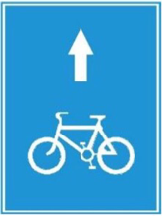 | 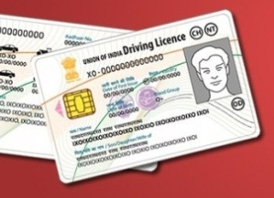 | 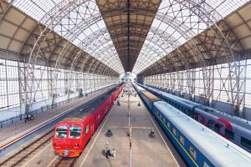
1. bus s_ _ _ | 2. c_ _ _ _ lane | 3. driving l_ _ _ _ _ _ | 4. r_ _ _ _ _ _ station
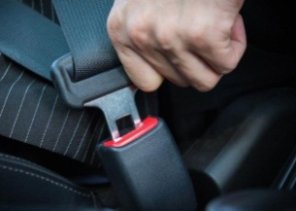 | 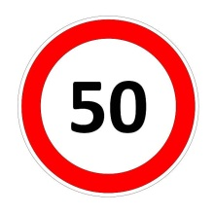 | 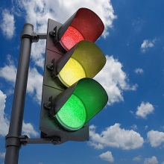 | 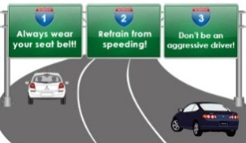
5. seat b_ _ _ | 6. s_ _ _ _ limit | 7. traffic l_ _ _ _ | 8. t_ _ _ _ _ _ rule
 |  | 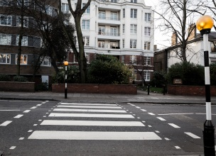
 | 9. train t_ _ _ _ _ | 10. z_ _ _ _ crossing
Exercise 3: Put the phrases under the correct road signs.
parking | no parking | no cycling | no right turn
zebra crossing | speed limit | no left turn | hospital ahead

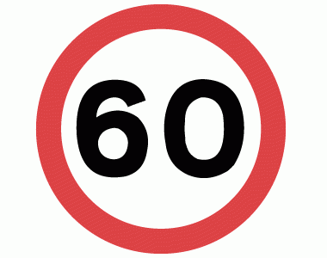 | 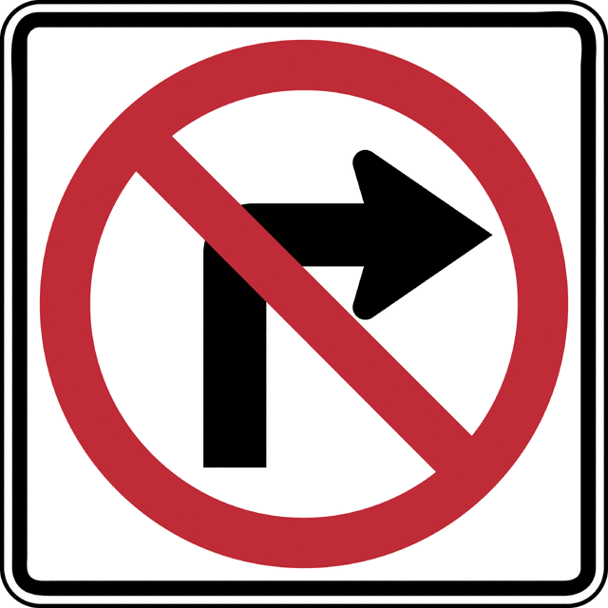 | 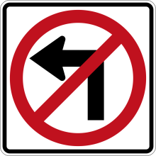 | 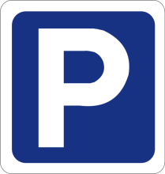
1 .............................. | 2 .............................. | 3 .............................. | 4 ..............................
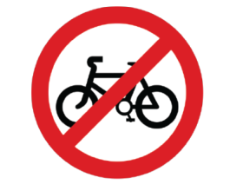 | 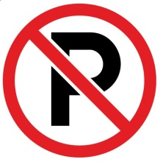 | 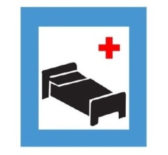 | 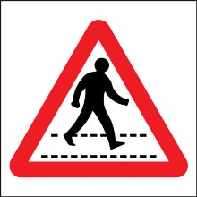
5 .............................. | 6 .............................. | 7 .............................. | 8 ..............................
Exercise 4: Choose the best option to fill in the blank.
1. There used to be fewer people and .................. on the roads.
A. roofs B. helmets C. helicopters D. vehicles
2. Do you know the .................. in the UK is to keep to the left?
A. traffic light B. traffic rule C. traffic jam D. speed limit
3. It is dangerous to ride a motorbike without a ..................
A. helmet B. triangle C. tricycle D. circle
4. In Hanoi, during rush hour, some road users ride their motorbikes on the ..................
A. driving licence B. lane C. pavement D. seat belt
5. Traffic is terrible during the .................. when everyone is in a hurry to get to work or come back home.
A. traffic light B. road sign C. traffic rule D. rush hour
6. The ................ for motorcycles is 40 km/h in towns and 60 km/h outside urban areas.
A. speed limit B. driving licence C. traffic rule D. traffic light
7. You must .................. the traffic rules in order to avoid accidents.
A. park B. obey C. reverse D. warn
8. It takes us more than three hours to drive across those .................. roads.
A. wide B. safely C. right-handed D. bumpy
9. You need a driving licence to ..................
A. drive a car B. ride a bike C. get on the bus D. get off the train
10. The large supermarkets in Vietnam often let you .................. free.
A. park B. obey C. warn D. find
11. Some vehicles beep when they .................. to warn those behind.
A. ride B. reverse C. drive D. sail
12. After school, children queue up and wait for the bus .................. on the pavement in front of the school.
A. safe B. bumpy C. safety D. safely
Exercise 5: Changed into negative and interrogative form.(chuyển sang câu phủ định và câu hỏi)
1. They used to play tennis twice a week.

2. I used to go to the gym three times a week.

3. Tennis used to be a sport for rich people only.

4. My father used to take me to see soccer games on Saturday.

5. He used to buy a new tennis racket.

Exercise 6: Rewrite the sentences with "used to".
1. They often went to Da Lat in the summer.

2. We usually played soccer in the past.

3. I got up earlier when I had work.

4. Tom did his homework in the evening.

5. Lan wrote to Mary twice a month.

6. He worked at night when he worked in the supermarket.

7. Did they watch TV in the past?

8. She played badminton in her free time.

9. They went swimming in the afternoon in 1990.

10. He was a doctor in that hospital.

Exercise7: Complete the dialogue with available words/ phrases.
welcome | bicycle | two | visit
How far | opposite | Excuse me | turn right
Khang: We are going to (1) ........................... the National Museum.
Lan: Great. I like to go there. (2) ..................... is it from my house to the museum?
Khang: It’s about (3) ........................... kilometers.
Lan: It’s not too far. How are we going there?
Khang: We are going there by (4) ...........................
Lan: Okay. Let’s go.
Khang: (5) ..........................., where is the National Museum?
Woman: Go straight for about 100 meters, (6) ......................., go straight again for 200 meters and turn left. The museum is (7) ........................ the Italian restaurant.
Khang and Lan: Thank you very much.
Woman: You’re (8) ...........................
Exercise 8: Read and decide if each statement is true or false or not given.
Hello. My name is Lucy. Last week I went to visit my friend Samantha in Spring Town. That was my first visit to Spring Town, and I rode my motorbike to Samantha’s house. Firstly I saw a No U-turn signal. So I had to ride forward until I see a U-turn signal. I turned and kept riding, then I noticed the crossroad sign and check my map. I saw that I had to turn left. But the red traffic light was on, and I had to wait for 60 seconds. I turned left and I got stuck in a traffic jam. I waited there for nearly 15 minutes. There was a car accident there, a car hit a motorbike and ran. At that time the motorcyclist was moved to the hospital. I could keep my riding. Unfortunately, my phone was out of charge, so I could not check my map and had to ask people there for route. After one hour and 02 times of getting lost, I finally reached my friend’s home. It is unbelievable.
No. | Statements | T | F | NG
1. | Samantha and Lucy lives in Spring Town.
2. | Lucy rode her bike to Samantha’s house.
3. | Lucy turned back when she saw No U-turn signal.
4. | It was about 02 kilometers from Lucy'’s house to Samantha’s house.
5. | The red traffic light was on for one minute.
6. | Lucy did not get stuck in traffic jam.
7. | There was an accident on the way to Samantha’s house.
8. | Lucy got lost one time on the way to Samantha’s house.

Exercise 9: Read and answer the questions.
TRAFFIC JAM
For many years, Daniel has been driving to work and back home every weekday. Every morning, on his way to work, especially during rush hours, the highways are usually crowded causing traffic jam. The situation is even worse in the evening when he drives home. If there is an accident or a car has broken down and block the lane, most of drivers have to wait for hours or turn back to go on another route. In the winter, especially when it snows, it is strongly for vehicles to move on thick layer of snow. Many people have to leave their vehicles outside and walk home because they completely cannot move. Daniel feels really tired when he is stuck in a traffic jam, so he usually listens to music and waits until the end of traffic jam.
1. How does Daniel go to work?

2. What happen with the highways during rush hours?

3. What do the drivers do when the lane is block?

4. Why is it difficult for vehicles to move in winter?

5. How is the lawyer of snow?

6. What do some people do when their cars are stuck in snow?

7. How does Daniel feel when he is stuck in a traffic jam?

8. What does Daniel do while waiting until the end of traffic jam?

Exercise 10: Answer the questions.
1. How far is it from your house to your school?

2. How do you go to school?

3. Is there a bus stop near your home?

4. Do you have a driving license?

5. What bus did you catch yesterday?

6. Is there a no-cycling sign near your house?

7. Have you travelled by plane? If yes, where have you gone?

8. What should we do when we see the red light?

Exercise 11: Write a short paragraph about the traffic in your city.

………………………………………………………………………………………………………………………………………………………………………………………………………………………………………………………………………………………………………………………………………………………………………………………………………………………………………………………………………………………………………………………………………………………………………

…………………………………………………………………………………………………

UNIT 7: TRAFFIC
WEEK 1

Exercise 1: Choose the word which has the underlined part pronounced differently from the others.
1. B 2. C 3. D 4. A 5. B
6. A 7. C 8. D 9. A 10. C
Exercise2. a: Look at the pictures and complete the phrases under them.
1. bus stop 6. speed limit
2. cycle lane 7. traffic light
3. driving license 8. traffic rule
4. railway station 9. train ticket
5. seat belt 10. zebra crossing
Exercise 3: Put the phrases under the correct road signs.
1. speed limit 2. no right turn 3. no left turn
4. parking 5. no cycling 6. hospital ahead
7. no parking 8. zebra crossing
Exercise 4: Choose the best option to fill in the blank.
1. D 2. B 3. A 4. C 5. D 6. A
7. B 8. D 9. A 10. A 11. B 12. D
Exercise 5: Changed into negative and interrogative form.
1. They didn’t use to play tennis twice a week.
Did they use to play tennis twice a week?
2. I didn’t use to go to the gym three times a week.
Did you use to go to the gym three times a week?
3. Tennis didn’t use to be a sport for rich people only.
Did tennis use to be a sport for rich people only?
4. My father didn’t use to take me to see soccer games on Saturday.
Did your father use to take you to see soccer games on Saturday?
5. He didn’t use to buy a new tennis racket?
Did he use to buy a new tennis racket?
Exercise 6: Rewrite the sentences with “used to”.
1. They used to go to Da Lat in the summer.
2. We used to play soccer in the past.
3. I used to get up earlier when I had work.
4. Tom used to do his homework in the evening.
5. Lan used to write to Mary twice a month.
6. He used to work at night when he worked in the supermarket.
7. Did they use to watch TV in the past?
8. She used to play badminton in her free time.
9. They used to go swimming in the afternoon in 1990.
10. He used to be a doctor in that hospital.

Exercise 7: Complete the dialogue with available words/ phrases.
1. visit 2. How far 3. two 4. bicycle
5. Excuse me 6. turn right 7. opposite 8. welcome
Exercise 8: Read and decide if each statement is true or false or not given.
1. F 2. T 3. F 4. NG 5. T 6. F 7. T 8. F
Exercise 9: Read and answer the questions.
1. He drives to work.
2. They are usually crowded causing traffic jam.
3. They wait for hours or turn back to go on another route.
4. Because of the snow.
5. It is thick.
6. They leave their vehicles outside and walk home.
7. He feels really tired.
8. He usually listens to music.
Exercise 10: Answer the questions.
1. It is about 500 meters.
2. My father drives me there.
3. Yes, there is.
4. No, I don’t.
5. I catch the bus No. 50 to go to the City Library.
6. No, there isn’t.
7. Yes, I have. I have travelled to Rome.
8. We should stop and wait.
Exercise 11: Write a short paragraph about the traffic in your city.
My name is Tuan. I live in Ha Noi. Ha Noi is a big and busy city. There are lots of vehicles on the road all day. There are lots of cars, buses, taxis and trucks on high ways. Vietnamese people like moving by motorbike. Almost every family has a motorbike. The traffic is the busiest at about 7 a.m and 5 p.m because it’s the time when people go to work or school and come back home. There are sometimes accidents on the road. We need to obey traffic rules to reduce accidents as much as possible.

